National Physical Fitness & Sports Month:

NYSS Champions Promotion Toolkit
May 2024

Overview
Since 1983, each President has proclaimed May as National Physical Fitness and Sports Month to promote the importance of physical activity, physical fitness, and sports participation. The Office of Disease Prevention and Health Promotion (ODPHP) and the President’s Council on Sports, Fitness & Nutrition (PCSFN) invite you to join in this celebration. This year, we are focusing on how physical activity and sports can positively impact mental health.
Use this toolkit to spread the word about National Physical Fitness and Sports Month and help your community learn about the physical and mental health benefits of moving more!

What’s in this toolkit?
This toolkit includes:
- How to join the conversation
- Key resources
- Sample social media messages
- Promotional graphics
- National Physical Fitness & Sports Month virtual background

Tips for Promoting National Physical Fitness & Sports Month on Social Media
- Pair your messages with the promotional graphics provided
  - Messages that link to videos will automatically add an image to your post — no graphic needed
- Use the #MoveYourWay or #MoveInMay hashtags
- Tag ODPHP and PCSFN on social media
  - Twitter/X: @HealthGov and @FitnessGov
  - Facebook: @Health.gov
  - LinkedIn: HHS OASH Office of Disease Prevention and Health Promotion

Join the Conversation
We want to hear from you! Share your favorite ways to move — and tell us why physical activity is important to you and how getting active supports your mental health.
- Lots of things count as physical activity. See how members of the President's Council on Sports, Fitness & Nutrition like to get active, and then share a photo or a video showing off your favorite way to move. Use the hashtag #WhatsYourMove and tag a friend or family member to challenge them to go next!
- Physical activity can boost your mood, sharpen your focus, reduce your stress, and improve your sleep. Take a break by moving your body and encourage others to do the same! Use the hashtag #MentalHealthMatters and share how physical activity benefits your mental health.
- Working with teens?
  - Encourage teens to participate in the #GetYour60 challenge by recording a video to show how they like to be physically active. Share the “Tips for Creating Your Own Move Your Way® Teen Video” fact sheet with teens to help them get started.

Key Resources
- Use the Move Your Way® Campaign to promote the physical and mental health benefits of physical activity.
- Explore 10 Actionable Tips: Support Youth Mental Health Through Sports to see how parents, coaches, and other youth sports leaders can support youth mental health through sports.
- Read the Surgeon General’s Perspective, Physical Activity: An Untapped Resource to Address Our Nation’s Mental Health Crisis Among Children and Adolescents to learn more about physical activity and youth mental health.
- Learn how school connectedness can support youth mental health, and how physical activity can help.

Sample Social Media Messages
Help your audiences find new ways to move by sharing these sample social media messages.

General
- May is National Physical Fitness & Sports Month! We’re joining @FitnessGov in celebrating the benefits of #PhysicalActivtiy! Feel better, improve sleep, and make social connections – all by being active! Learn more about physical activity: https://health.gov/moveyourway
- It’s National Physical Fitness & Sports Month! Check out @Healthgov’s directory of #NYSSChampions to see how organizations like ours are promoting youth sports across the country! https://go.usa.gov/xHTS7
- #DYK? Physical activity can reduce feelings of anxiety and depression and improve sleep – and all sorts of activities count! Check out how members of @FitnessGov like to #GetActive: https://www.youtube.com/watch?v=Kqjs8c4FGaA #MentalHealthMatters
- Happy National Physical Fitness & Sports Month! Are you ready to #MoveYourWay in May? Getting active can improve physical and #MentalHeatlh – and everyone can benefit! Find your way to move today: https://go.usa.gov/xH2Qk #MoveInMay

Parents
- Parents: #PhysicalActivity and #YouthSports have benefits for kids that go way beyond physical health. Learn more with @HealthGov’s #MoveYourWay video: https://bit.ly/3LCwRG4 #MoveInMay
- #DYK? Sports can help youth develop confidence and boost self-esteem. Check out this #MoveYourWay fact sheet from @HealthGov for tips to help your kids get in the game: https://bit.ly/3wjwHPp #MentalHealthMatters
- It’s #NationalAdolescentHealthMonth! Let’s get our kids moving – for their physical and #MentalHealth. Kids and teens need at least 60 minutes of physical activity each day. Find ways to get your kids moving with @Healthgov’s interactive graphic: https://go.usa.gov/xH2Pg
- Are you involved in #YouthSports? Whether you’re a parent, coach, or volunteer, you can help support youth mental health with these 10 tips: https://health.gov/sites/default/files/2022-05/Youth%20Sports%20Infographic_2022.05_508c.pdf #MoveInMay #MentalHealthMatters

Promotional Graphics
Pair your social media messages with a promotional graphic!
Main Graphic

Formatted for Facebook, LinkedIn, Twitter/X
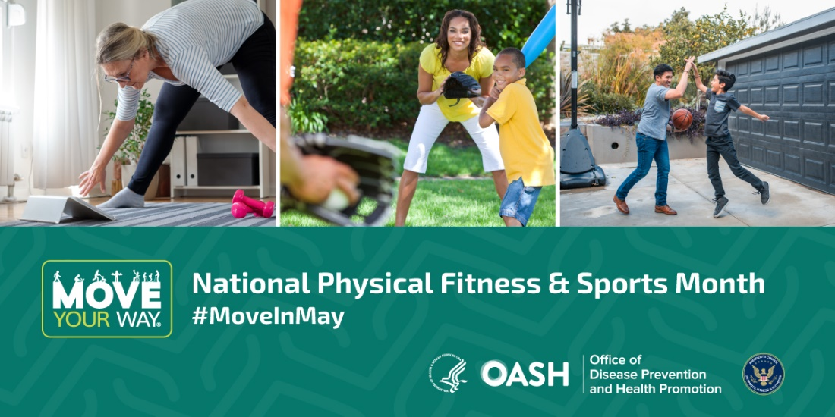

Formatted for Instagram
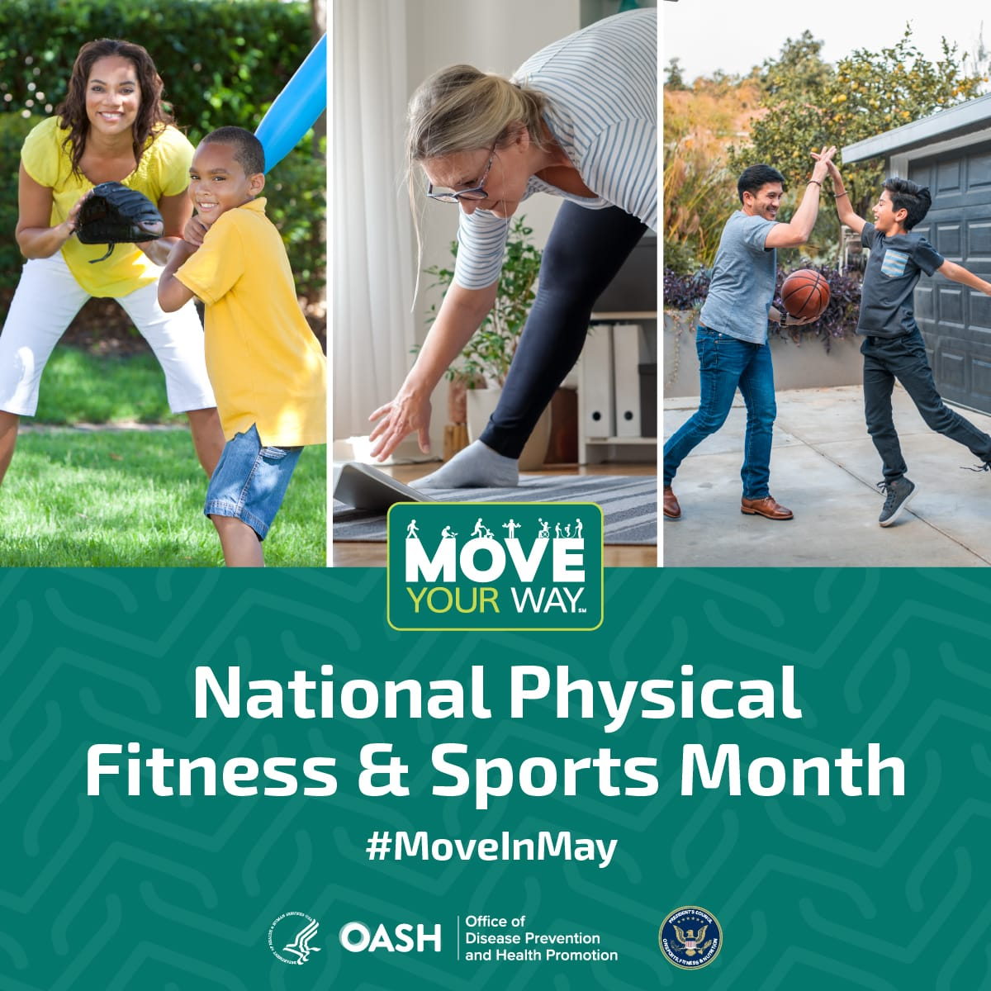

Additional Promotional Graphics
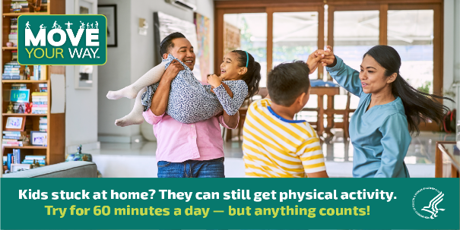
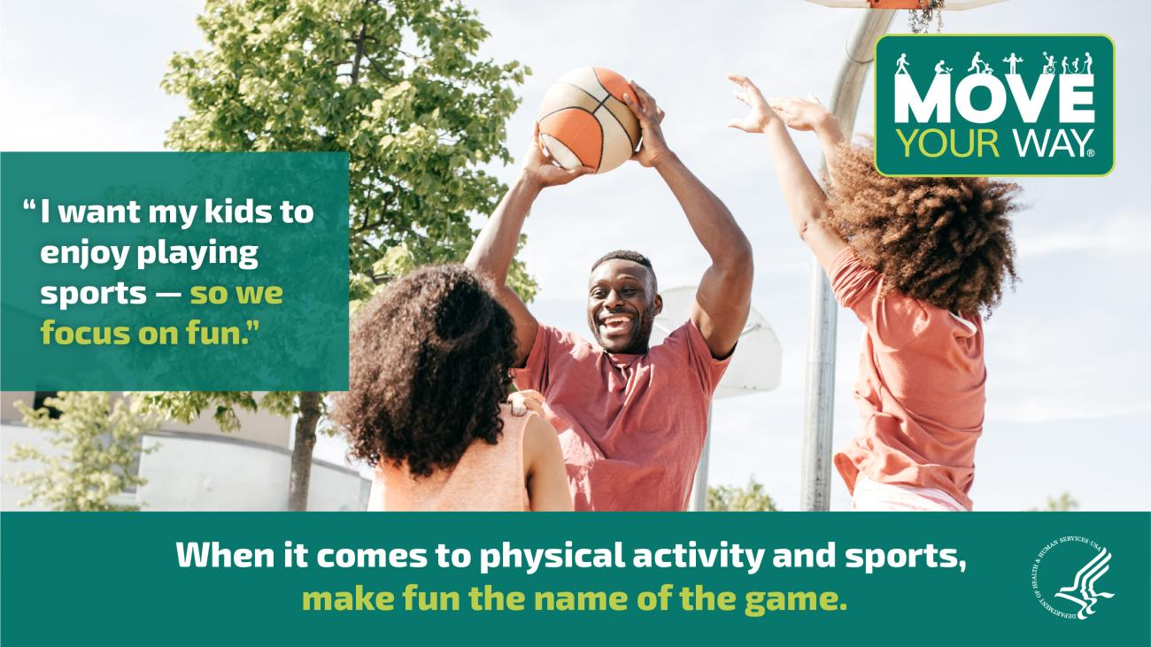
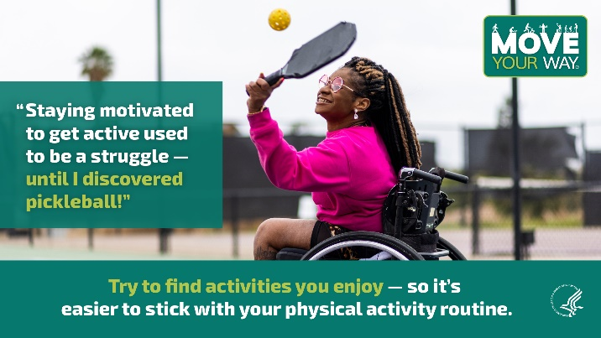
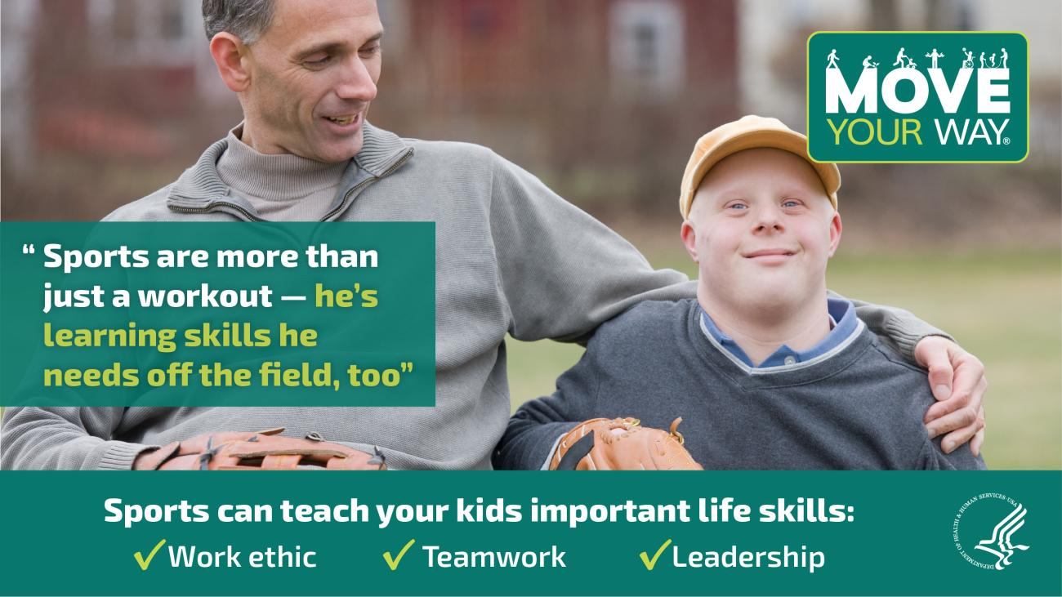
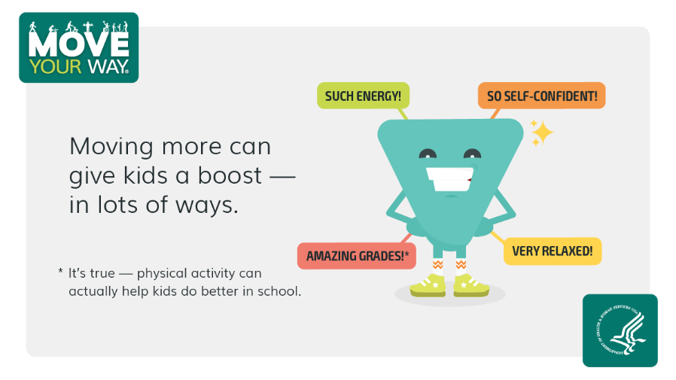
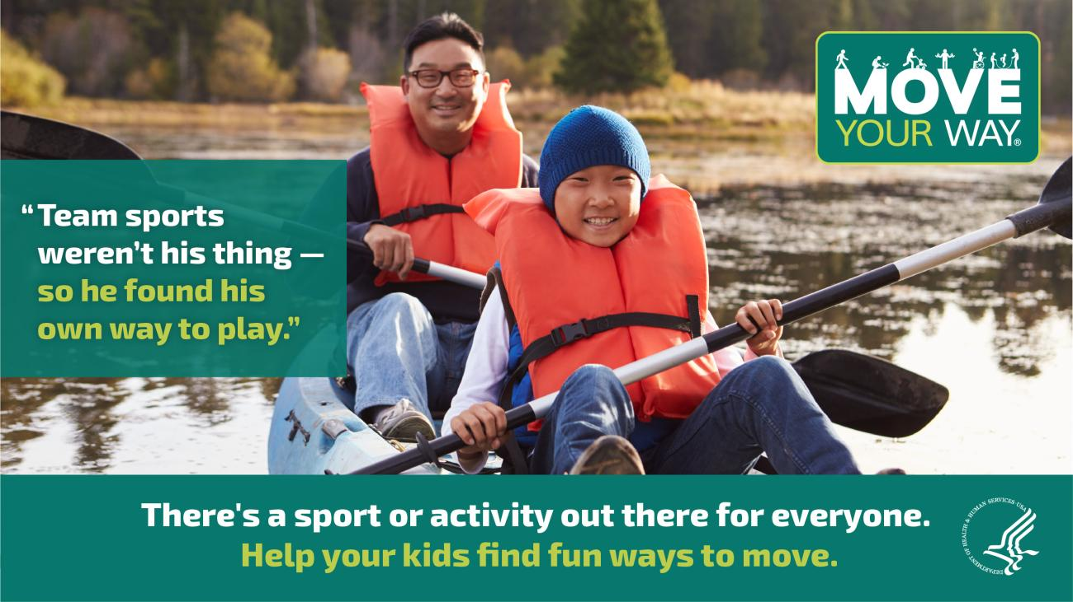

Virtual Background
Use the National Physical Fitness & Sports Month virtual background to promote physical activity all month long! Download the attached file for a high-resolution image.
